Relationship

The association among entities is called a relationship. For example, an employee **works_at** a department, a student**enrolls** in a course. Here, Works_at and Enrolls are called relationships.

Relationship Set

A set of relationships of similar type is called a relationship set. Like entities, a relationship too can have attributes. These attributes are called **descriptive attributes**.

Degree of Relationship

The number of participating entities in a relationship defines the degree of the relationship.

* Binary = degree 2
* Ternary = degree 3
* n-ary = degree

Mapping Cardinalities

**Cardinality** defines the number of entities in one entity set, which can be associated with the number of entities of other set via relationship set.

* **One-to-one** − One entity from entity set A can be associated with at most one entity of entity set B and vice versa.

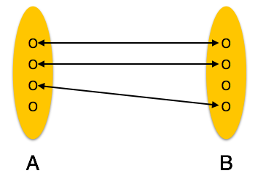

* **One-to-many** − One entity from entity set A can be associated with more than one entities of entity set B however an entity from entity set B, can be associated with at most one entity.

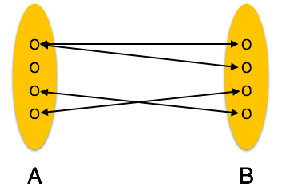

* **Many-to-one** − More than one entities from entity set A can be associated with at most one entity of entity set B, however an entity from entity set B can be associated with more than one entity from entity set A.

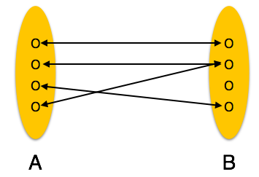

* **Many-to-many** − One entity from A can be associated with more than one entity from B and vice versa.

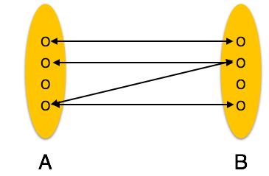

Let us now learn how the ER Model is represented by means of an ER diagram. Any object, for example, entities, attributes of an entity, relationship sets, and attributes of relationship sets, can be represented with the help of an ER diagram.

## Entity

Entities are represented by means of rectangles. Rectangles are named with the entity set they represent.



Attributes

Attributes are the properties of entities. Attributes are represented by means of ellipses. Every ellipse represents one attribute and is directly connected to its entity (rectangle).

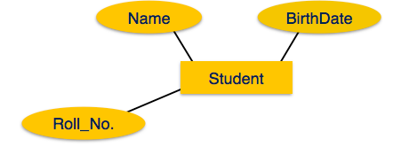

If the attributes are **composite**, they are further divided in a tree like structure. Every node is then connected to its attribute. That is, composite attributes are represented by ellipses that are connected with an ellipse.

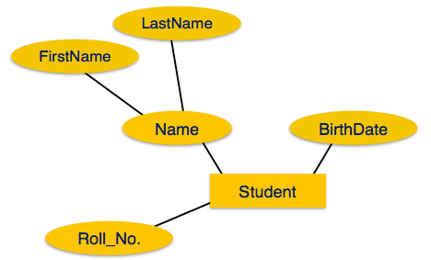

**Multivalued** attributes are depicted by double ellipse.

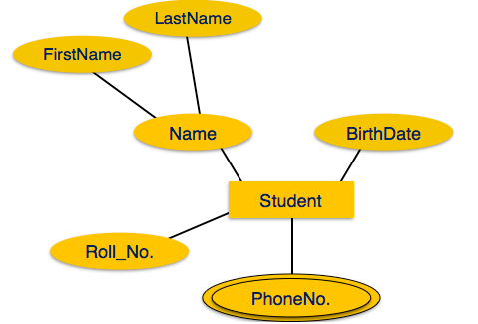

**Derived** attributes are depicted by dashed ellipse.

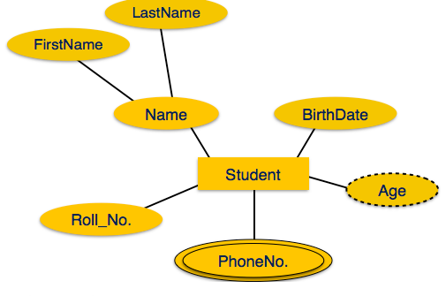

## Relationship

Relationships are represented by diamond-shaped box. Name of the relationship is written inside the diamond-box. All the entities (rectangles) participating in a relationship, are connected to it by a line.

### Binary Relationship and Cardinality

A relationship where two entities are participating is called a**binary relationship**. Cardinality is the number of instance of an entity from a relation that can be associated with the relation.

* **One-to-one** − When only one instance of an entity is associated with the relationship, it is marked as '1:1'. The following image reflects that only one instance of each entity should be associated with the relationship. It depicts one-to-one relationship.

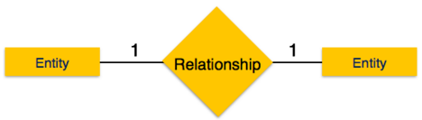

* **One-to-many** − When more than one instance of an entity is associated with a relationship, it is marked as '1:N'. The following image reflects that only one instance of entity on the left and more than one instance of an entity on the right can be associated with the relationship. It depicts one-to-many relationship.

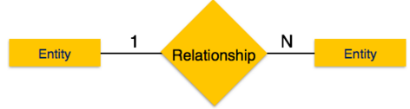

* **Many-to-one** − When more than one instance of entity is associated with the relationship, it is marked as 'N:1'. The following image reflects that more than one instance of an entity on the left and only one instance of an entity on the right can be associated with the relationship. It depicts many-to-one relationship.

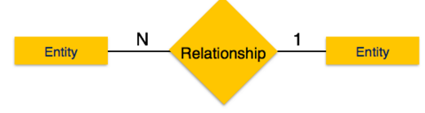

* **Many-to-many** − The following image reflects that more than one instance of an entity on the left and more than one instance of an entity on the right can be associated with the relationship. It depicts many-to-many relationship.

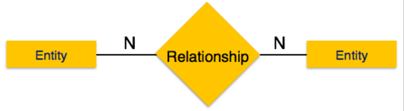

### Participation Constraints

* **Total Participation** − Each entity is involved in the relationship. Total participation is represented by double lines.
* **Partial participation** − Not all entities are involved in the relationship. Partial participation is represented by single lines.

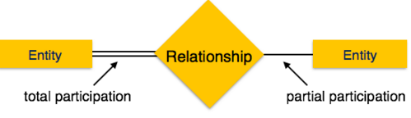

## Generalization

As mentioned above, the process of generalizing entities, where the generalized entities contain the properties of all the generalized entities, is called generalization. In generalization, a number of entities are brought together into one generalized entity based on their similar characteristics. For example, pigeon, house sparrow, crow and dove can all be generalized as Birds.

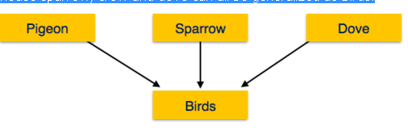

## Specialization

Specialization is the opposite of generalization. In specialization, a group of entities is divided into sub-groups based on their characteristics. Take a group ‘Person’ for example. A person has name, date of birth, gender, etc. These properties are common in all persons, human beings. But in a company, persons can be identified as employee, employer, customer, or vendor, based on what role they play in the company.

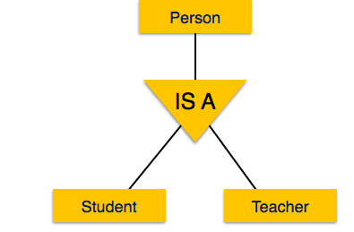

Dr Edgar F. Codd, after his extensive research on the Relational Model of database systems, came up with twelve rules of his own, which according to him, a database must obey in order to be regarded as a true relational database.

These rules can be applied on any database system that manages stored data using only its relational capabilities. This is a foundation rule, which acts as a base for all the other rules.

## Rule 1: Information Rule

The data stored in a database, may it be user data or metadata, must be a value of some table cell. Everything in a database must be stored in a table format.

## Rule 2: Guaranteed Access Rule

Every single data element (value) is guaranteed to be accessible logically with a combination of table-name, primary-key (row value), and attribute-name (column value). No other means, such as pointers, can be used to access data.

## Rule 3: Systematic Treatment of NULL Values

The NULL values in a database must be given a systematic and uniform treatment. This is a very important rule because a NULL can be interpreted as one the following − data is missing, data is not known, or data is not applicable.

## Rule 4: Active Online Catalog

The structure description of the entire database must be stored in an online catalog, known as **data dictionary**, which can be accessed by authorized users. Users can use the same query language to access the catalog which they use to access the database itself.

## Rule 5: Comprehensive Data Sub-Language Rule

A database can only be accessed using a language having linear syntax that supports data definition, data manipulation, and transaction management operations. This language can be used directly or by means of some application. If the database allows access to data without any help of this language, then it is considered as a violation.

## Rule 6: View Updating Rule

All the views of a database, which can theoretically be updated, must also be updatable by the system.

## Rule 7: High-Level Insert, Update, and Delete Rule

A database must support high-level insertion, updation, and deletion. This must not be limited to a single row, that is, it must also support union, intersection and minus operations to yield sets of data records.

## Rule 8: Physical Data Independence

The data stored in a database must be independent of the applications that access the database. Any change in the physical structure of a database must not have any impact on how the data is being accessed by external applications.

## Rule 9: Logical Data Independence

The logical data in a database must be independent of its user’s view (application). Any change in logical data must not affect the applications using it. For example, if two tables are merged or one is split into two different tables, there should be no impact or change on the user application. This is one of the most difficult rule to apply.

## Rule 10: Integrity Independence

A database must be independent of the application that uses it. All its integrity constraints can be independently modified without the need of any change in the application. This rule makes a database independent of the front-end application and its interface.

## Rule 11: Distribution Independence

The end-user must not be able to see that the data is distributed over various locations. Users should always get the impression that the data is located at one site only. This rule has been regarded as the foundation of distributed database systems.

## Rule 12: Non-Subversion Rule

If a system has an interface that provides access to low-level records, then the interface must not be able to subvert the system and bypass security and integrity constraints.

**Properties of relational data model**

Relational data model is the primary data model, which is used widely around the world for data storage and processing. This model is simple and it has all the properties and capabilities required to process data with storage efficiency.

## Concepts

**Tables** − In relational data model, relations are saved in the format of Tables. This format stores the relation among entities. A table has rows and columns, where rows represents records and columns represent the attributes.

**Tuple** − A single row of a table, which contains a single record for that relation is called a tuple.

**Relation instance** − A finite set of tuples in the relational database system represents relation instance. Relation instances do not have duplicate tuples.

**Relation schema** − A relation schema describes the relation name (table name), attributes, and their names.

**Relation key** − Each row has one or more attributes, known as relation key, which can identify the row in the relation (table) uniquely.

**Attribute domain** − Every attribute has some pre-defined value scope, known as attribute domain.